Lab 3

Class id:32

Name : harshil l patel

Task1 – YouTube api

I have created a web page In which user can search for any keyword and video related to that keyword from youtube will be show there.

Steps:

1. Crated API key from google to get youtube video.
2. Created javascript code to use youtube api to get video data and show them on the site

Code:

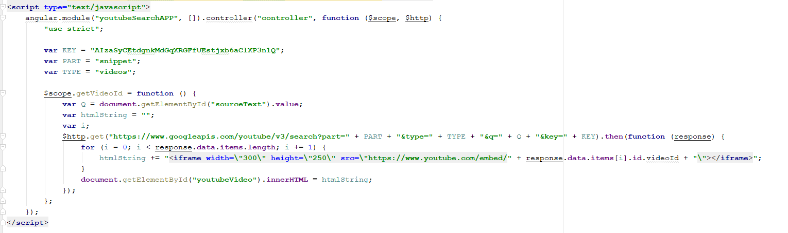

Output:

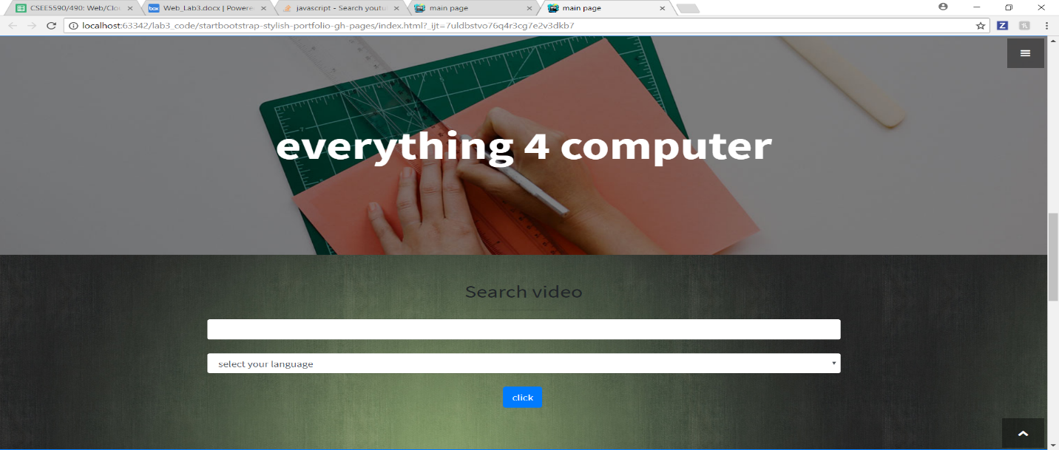

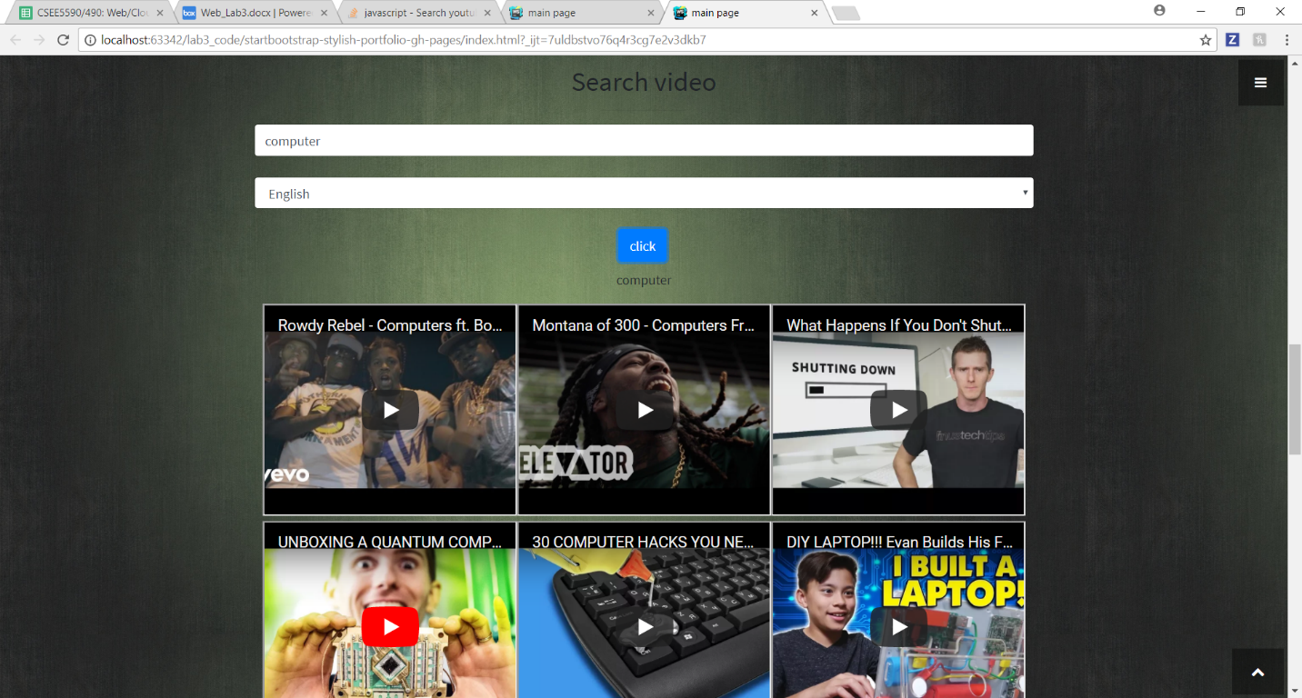

Task 2 : twitter api

Goal:

To create app which will retrieve friends name of the given user and show them with the help of D3.JS.

Step:

1. Create api key for twitter.
2. Created js code which will retrieve data of the given user and create data.json file which contain the friend list in the format which can be understand by d3.js
3. Use in class 6 code to show the retrieve data in the form of graph.

Code:

Here I am using my twitter api key to to restive data from twitter and than creating a dictionary to store the data and then to file name data.json

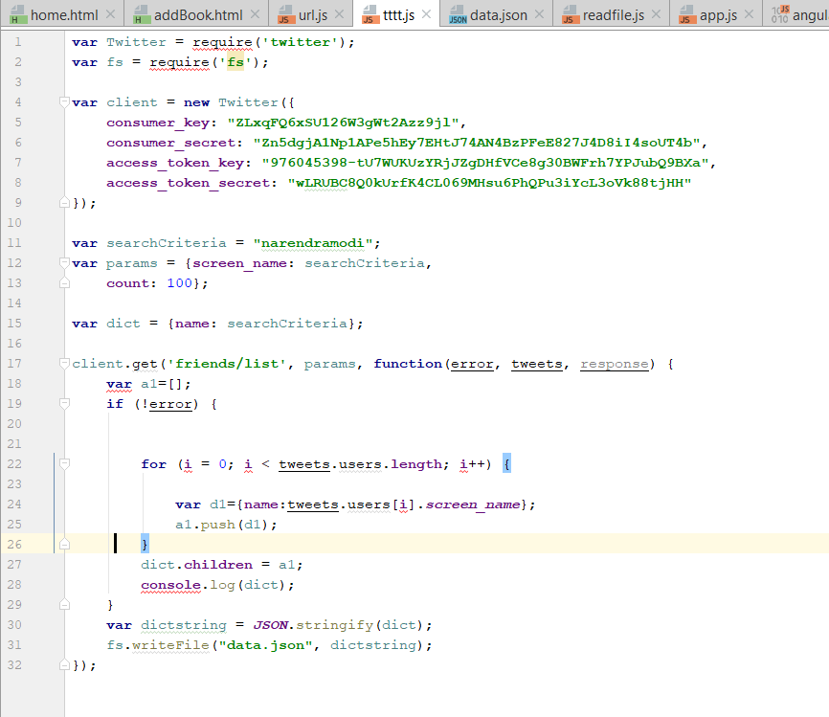

Data.json

This file will be created by the above code. This will contain the friend list.

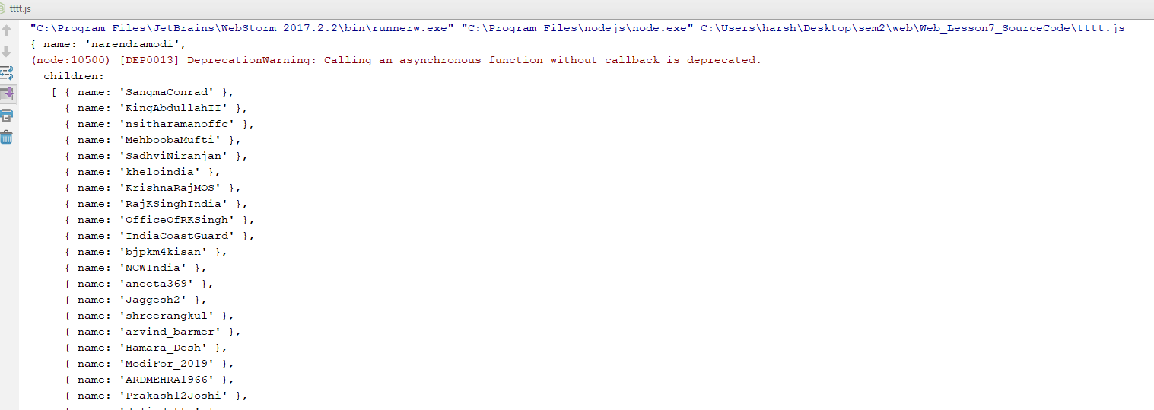

Output

